PRACTICAL 6:
1a:
Code:
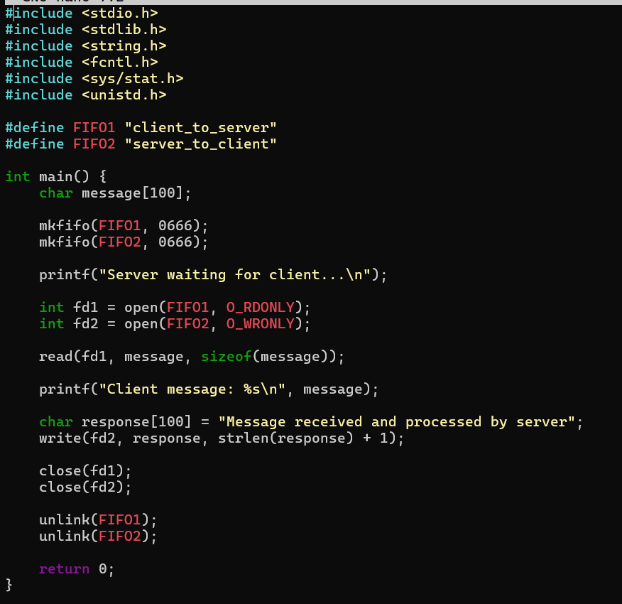
Output:
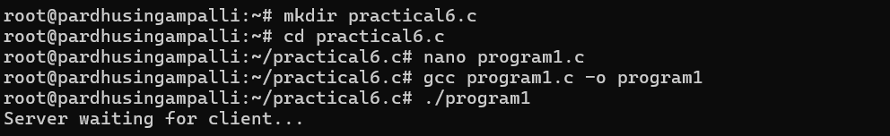

1b:
Code:
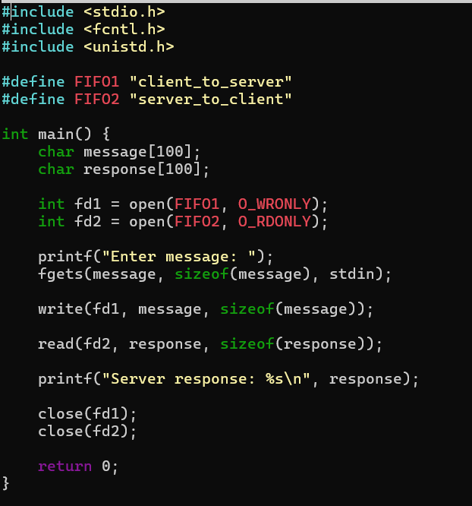
Output:
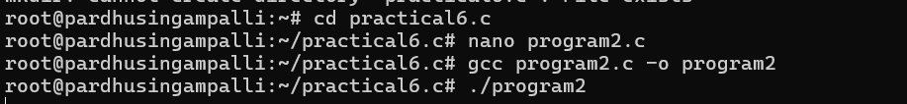

6b:
Code:
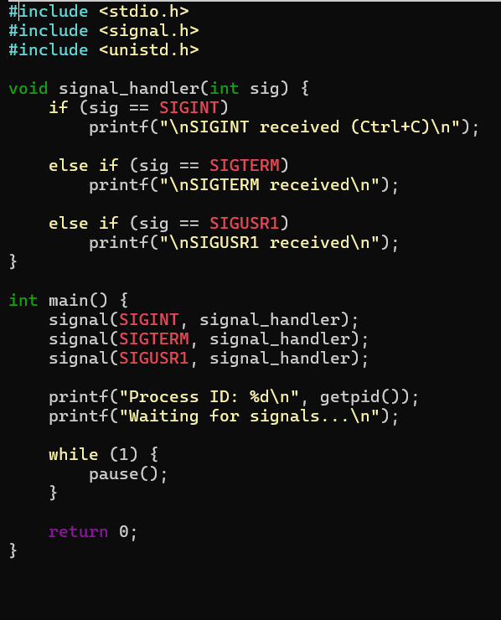
Output:
